Session 8
class Solution {
public int removeDuplicates(int[] nums) {
int k = 1;

for (int i = 1; i < nums.length; i++) {
if (nums[i] != nums[i - 1]) {
nums[k] = nums[i];
k++;
}
}

return k;
}
}
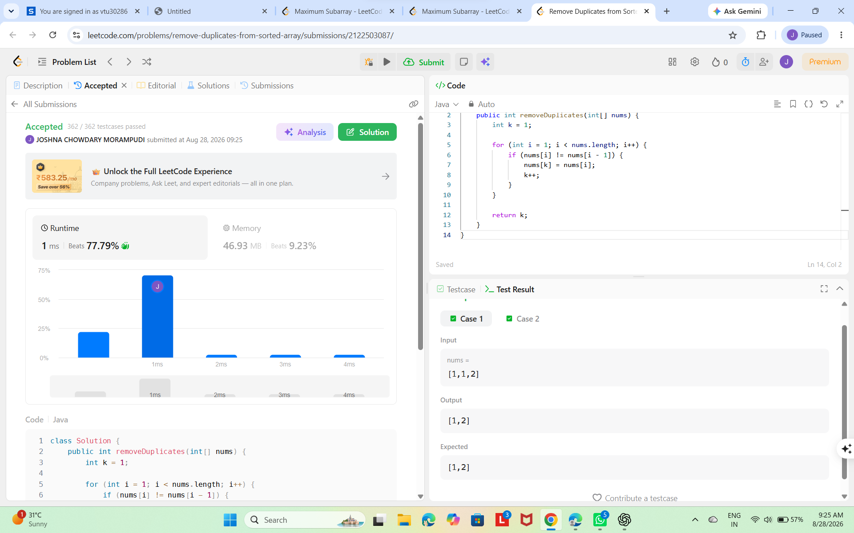
Session8.2
class Solution {
public int largestAltitude(int[] gain) {
int altitude = 0;
int maxAltitude = 0;

for (int i = 0; i < gain.length; i++) {
altitude = altitude + gain[i];

if (altitude > maxAltitude) {
maxAltitude = altitude;
}
}

return maxAltitude;
}
}